Sustained Lithium Nitrate Release in Gel Polymer Electrolytes Enabled by Bulk Reservoir
Xinyue Zhao^{a†}, Yu Zhao^{b†}, Kanghou Maª, Jingyi Hanª, Ningning Wu^{c}*, Yaohui Zhangª*
ª School of Physics, Harbin Institute of Technology, Harbin, Heilongjiang, 150001, China
^{b} School of Chemistry, Harbin Institute of Technology, Harbin, Heilongjiang, 150001, China
^{c} School of Electrical Engineering, Hebei University of Technology, Tianjin, 300401, China
†These authors contributed equally to this work and share first authorship
*Corresponding authors. E-mail address: hitcrazyzyh@hit.edu.cn, 2024042@hebut.edu.cn

Supplementary Figures
As shown in Figures S1 and S2, C-LiNO₃-10% GPE exhibits the best cycling performance among the samples with different LiNO₃ loadings. A lower loading provides insufficient interfacial regulation, whereas excessive LiNO₃ release may compromise membrane uniformity and ion transport; therefore, 10% was selected as the optimized loading for subsequent studies.
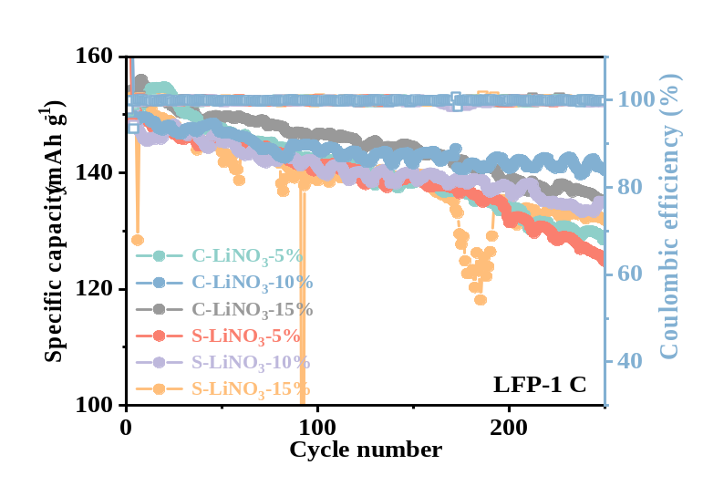
Figure S1. Cycling performance and Coulombic efficiency of LFP full cells using S-LiNO₃ and C-LiNO₃ GPEs with different LiNO₃ contents at 1 C.

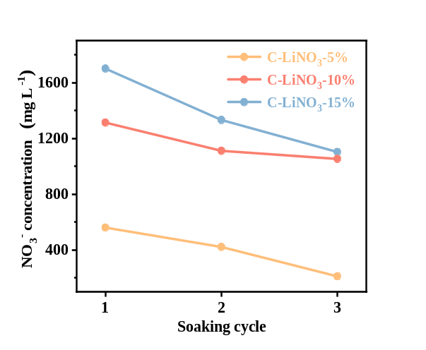
Figure S2. NO₃⁻ concentration changes in ester-based electrolyte after repeated soaking (6 h each) for C-LiNO₃-5%, C-LiNO₃-10% and C-LiNO₃-15% GPE.

Figure S3. Cross-sectional EDS mapping of a) S-LiNO₃ and b) C-LiNO₃ GPEs.

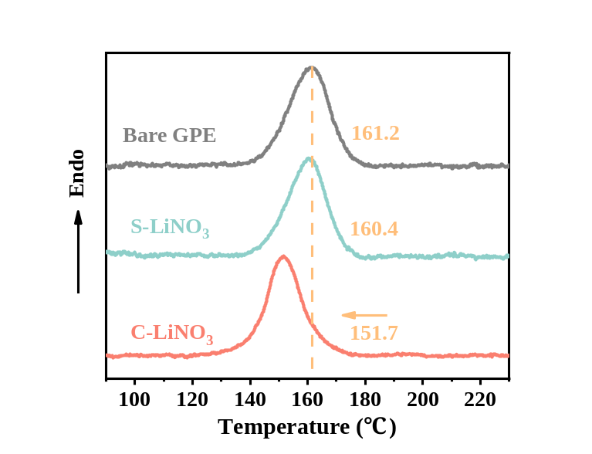
Figure S4. DSC comparison of Bare GPE, S-LiNO₃ GPE, and C-LiNO₃ GPE.
Table S1. The calculation results of the crystallinity of GPEs in DSC.
GPE | Crystallinity (%)
GPE | DSC
Bare GPE | 52.48
S-LiNO₃ GPE | 48.91
C-LiNO₃ GPE | 43.55
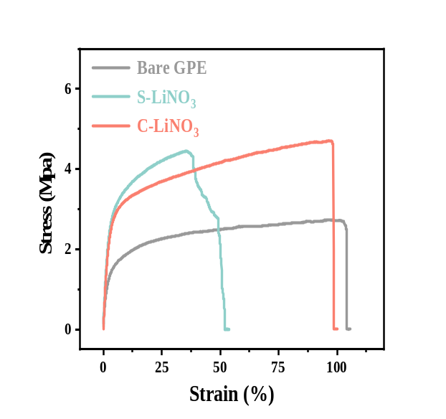
Figure S5. Tensile stress-strain curves of Bare GPE, S-LiNO₃ GPE, and C-LiNO₃ GPE.
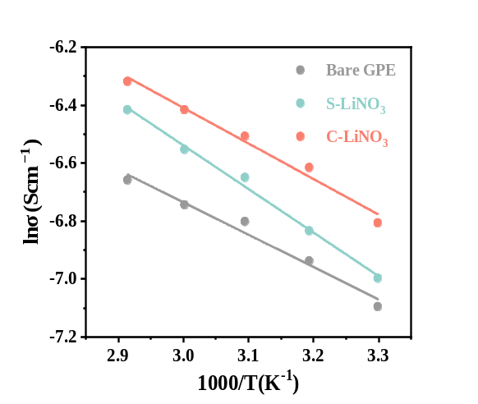
Figure S6. Corresponding Arrhenius plots of the Bare, S-LiNO₃, and C-LiNO₃ GPEs.

Table S2. Temperature-dependent ionic conductivities of the Bare, S-LiNO₃, and C-LiNO₃ GPEs.
Temperature  (℃) | 1000/T  (K⁻¹) | Bare | S-LiNO₃ | C-LiNO₃
30 | 3.2987 | 0.829 | 0.914 | 1.110
40 | 3.1934 | 0.970 | 1.080 | 1.340
50 | 3.0945 | 1.110 | 1.290 | 1.490
60 | 3.0017 | 1.180 | 1.430 | 1.640
70 | 2.9142 | 1.280 | 1.630 | 1.800

Table S3. Ionic conductivity at 30°C, Li⁺ transference number, apparent activation energy, and fitting coefficient of different GPEs.
GPE | σ_{30℃}  (10⁻³ S cm⁻¹) | T_{Li}⁺ | E_{a}  (kJ mol⁻¹) | R²
Bare | 0.829 | 0.31 | 9.56 | 0.9765
S-LiNO₃ | 0.914 | 0.56 | 12.46 | 0.9950
C-LiNO₃ | 1.110 | 0.62 | 10.06 | 0.9838

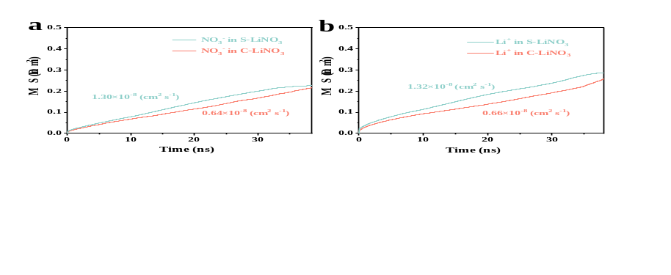
Figure S7. MSD curves and diffusion coefficients of a) NO₃⁻ and b) Li⁺ in S-LiNO₃ and C-LiNO₃ GPEs.

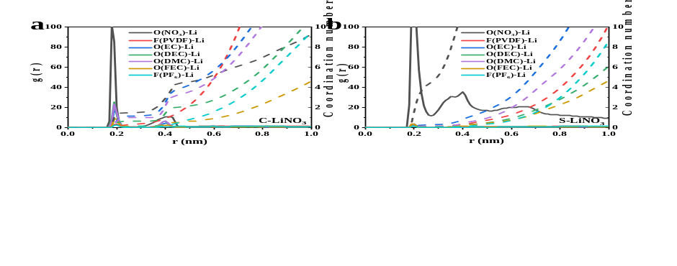
Figure S8. RDF profiles and coordination numbers of Li⁺ with NO₃⁻, PVDF, and solvent molecules in a) C-LiNO₃ and b) S-LiNO₃ GPEs.

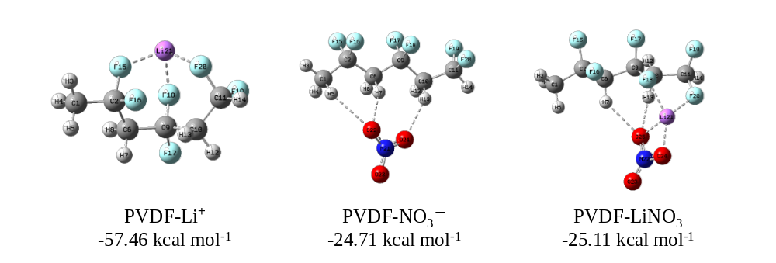
Figure S9. DFT-optimized structures and binding energies of PVDF with Li⁺, NO₃⁻, and LiNO₃ ion pairs.

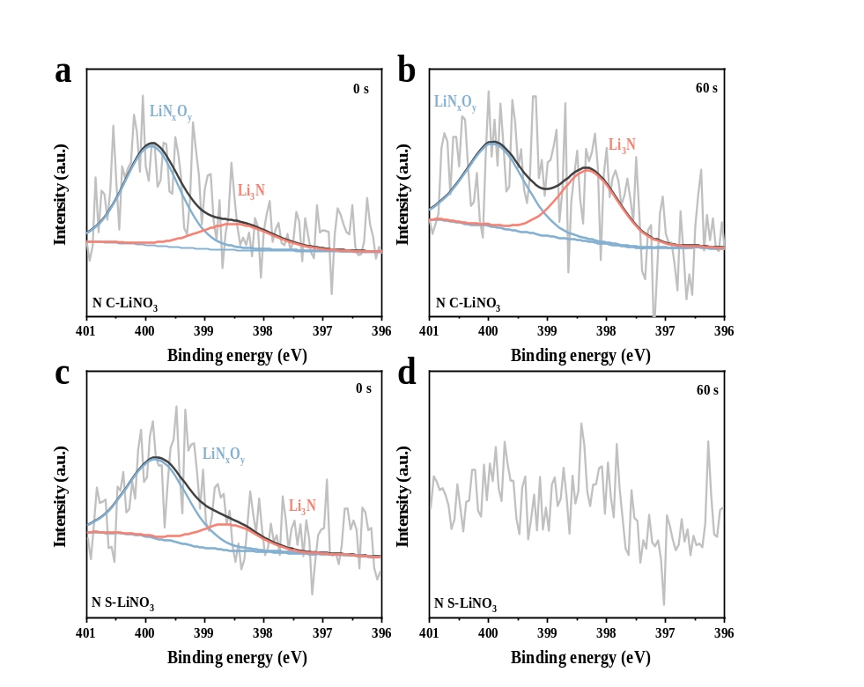
Figure S10. N 1s XPS spectra of Li anodes after 500 cycles at sputtering times of 0 and 60 s with a, b) C-LiNO₃ GPE; c, d) S-LiNO₃ GPE.

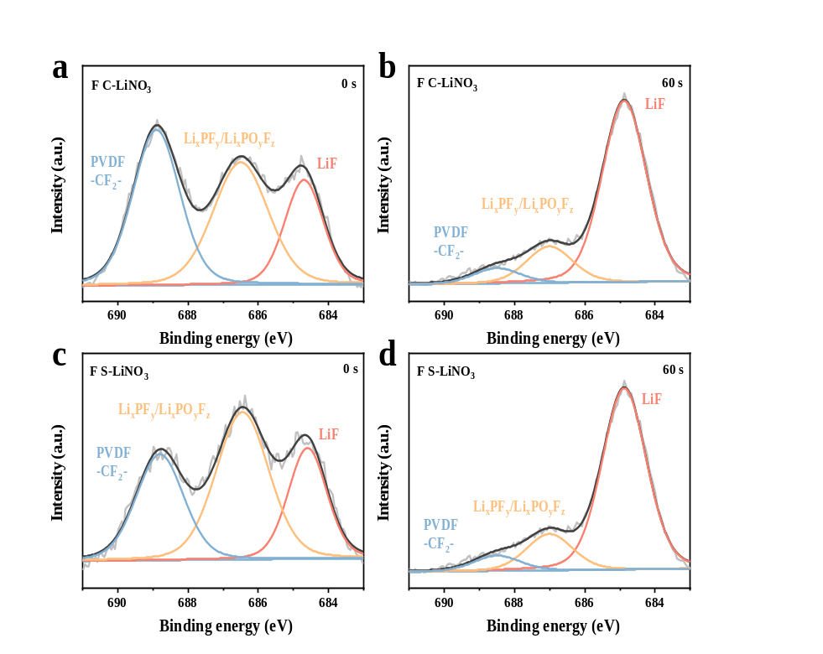
Figure S11. F 1s XPS spectra of Li anodes after 500 cycles at sputtering times of 0 and 60 s with a, b) C-LiNO₃ GPE; c, d) S-LiNO₃ GPE.

Figure S12. TOF-SIMS 2D distribution maps of lithium anode SEI after 50 cycles in S-LiNO₃.

Figure S13. TOF-SIMS 3D distribution map of lithium anode SEI after 50 cycles in S-LiNO₃.

Figure S14. TOF-SIMS 2D distribution map of lithium anode SEI after 50 cycles in the C-LiNO₃.

Figure S15. TOF-SIMS 3D distribution map of lithium anode SEI after 50 cycles in C-LiNO₃.

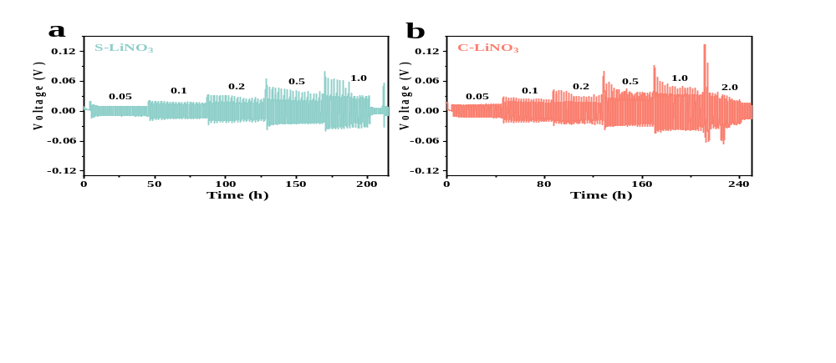
Figure S16. Stepwise critical current density measurements of Li‖Li symmetric cells using a) S-LiNO₃ GPE and b) C-LiNO₃ GPE.

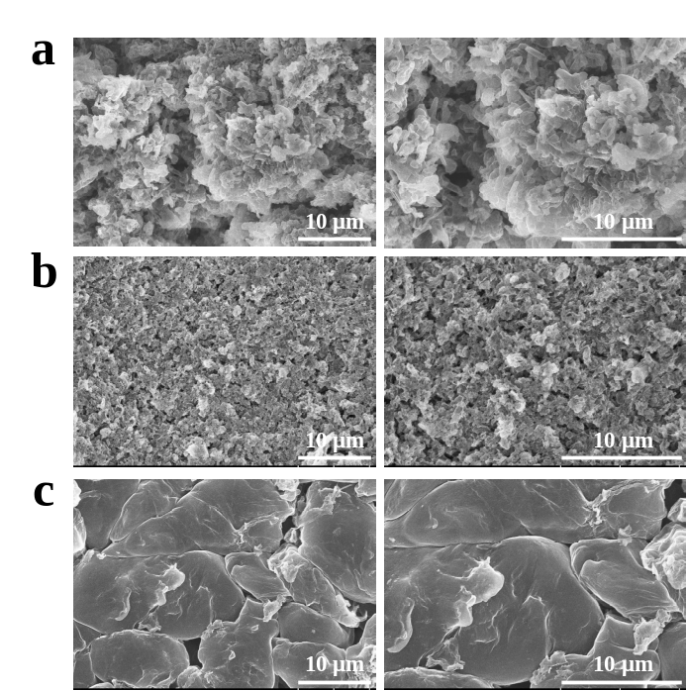
Figure S17. SEM images of lithium anodes after 500 cycles with a) Bare GPE; b) S-LiNO₃ GPE; c) C-LiNO₃ GPE.

Table S4. Comparison of reported LiNO₃ reservoir/release strategies with this work.
Ref. | LiNO₃ release strategy | Membrane/electrolyte system | Cell configuration | Representative performance
[1] | Separator-stored LiNO₃;  slow release | LiPF₆/carbonate + LiNO₃ separator | Li||Cu; Li-MoS₃ | CE > 98%@10/20 mAh cm⁻²
[2] | PP/LiNO₃/PP sandwich;  sustained NO₃⁻ release | Carbonate + bilayer PP separator | Li||Cu; Li||NCA | CE > 95.3%@550 cycles;  NCA: 103.8 mAh g⁻¹@500 cycles
[3] | LiNO₃@MOF nanocapsules;  continuous supply | Carbonate + MOF nanocapsules | Li||LCO | LCO: 90%@240 cycles;  LiNO₃-saturated electrolyte failed after ~60 cycles
[4] | Dissociated LiNO₃;  fast-release PVC interlayer | LNO-PVC organogel interlayer | Li||Cu;  Li||NCM811 pouch | CE 98.6%@300 cycles;  pouch: 400 Wh kg⁻¹, 65 cycles
[5] | Bilayer separator;  sustainable LiNO₃ release | Carbonate + bilayer separator | Li||LFP | LFP: 85%@800 cycles
[6] | LiNO₃-containing GPE;  polymer-network reservoir | PVDF-HFP/POSS/LiNO₃ GPE | Cu||Li;  Cu||NMC811 anode-free | Cu||Li: 250 cycles;  anode-free: 31.37%@50 cycles
[7] | Electrospun PVDF/LiNO₃ nanofibers;  localized release | PP + PVDF/LiNO₃ nanofiber coating | Li||Li;  Li||NMC622;  Cu||NMC622 anode-free | NMC622: 83%@100 cycles;  anode-free: 54%@50 cycles
This work | C-LiNO₃: bulk GPE reservoir;  S-LiNO₃: surface-loaded control | PVDF-based GPE | Li|GPE|Cu;  LFP anode-free;  NCM811|GPE|Li;  LFP|GPE|Li | CE 96.39%@185 cycles;  LFP anode-free: 151.16 mAh g⁻¹@115 cycles;  NCM811: 154.72 mAh g⁻¹@450 cycles;  high-loading LFP: 132.81 mAh g⁻¹@700 cycles, 88.68%;  LFP: 99.01 mAh g⁻¹@3000 cycles, 71.75%

Reference
- Shi, Q.; Zhong, Y.; Wu, M.; et al. High-capacity rechargeable batteries based on deeply cyclable lithium metal anodes. Proc. Natl. Acad. Sci. USA 2018, 115, 5676–5680. https://doi.org/10.1073/pnas.1803634115.
- Liu, Y.; Qin, X.; Zhou, D.; et al. A biscuit-like separator enabling high performance lithium batteries by continuous and protected releasing of NO3− in carbonate electrolyte. Energy Storage Mater. 2020, 24, 229–236. https://doi.org/10.1016/j.ensm.2019.08.016.
- Liu, Q.; Xu, Y.; Wang, J.; et al. Sustained-release nanocapsules enable long-lasting stabilization of Li anode for practical Li-metal batteries. Nano-Micro Lett. 2020, 12, 176. https://doi.org/10.1007/s40820-020-00514-1.
- Stuckenberg, S.; Bela, M.M.; Lechtenfeld, C.T.; et al. Influence of LiNO3 on the Lithium Metal Deposition Behavior in Carbonate‐Based Liquid Electrolytes and on the Electrochemical Performance in Zero‐Excess Lithium Metal Batteries. Small 2024, 20, 2305203. https://doi.org/10.1002/smll.202305203.
- Li, S.; Liu, Y.; Wang, K.; et al. Sustainable release of LiNO3 in carbonate electrolytes for stable lithium metal anodes. Chem. Commun. 2024, 60, 2649–2652. https://doi.org/10.1039/d3cc05859j.
- Yim, T.; Kim, K.; Hassig, M.Q.; et al. Lithium-Nitrate-Containing Gel Polymer Electrolyte for Carbonate-Based Anode-Free Lithium Metal Batteries. ACS Appl. Mater. Interfaces 2025, 17, 37851–37862. https://doi.org/10.1021/acsami.5c03252.
- Haidar, A.H.; Hawari, N.H.; Anggreini, D.; et al. PVDF Nanofiber Separator with Sustained LiNO3 Additive Release for Dendrite-Suppressed Anode-Free Lithium Metal Batteries. J. Mater. Chem. A 2026, 14, 12449–12460. https://doi.org/10.1039/d5ta09302c.

