Additional Experimental Section

Reagents and Materials
The 6-mercapto-1-hexanol (MCH) was obtained from Sigma-Aldrich (Shanghai, China). Methylene blue (MB) and hydrochloric acid (HCl) were supplied by Sinopharm Chemical Reagent Co., Ltd. tris(2-carboxyethyl)phosphine solution (TCEP), 1,2-bis(dimethylamino)-ethane (TEMED), Tris(hydroxymethyl)aminomethane (Tris), 40% acrylamide mix solution, ammonium persulfate (APS), and the nucleic acids used in this study were acquired from Sangon Biotechnology Co., Ltd. (Shanghai, China). The specific sequences are provided in Table S1. The stock solution of each nucleic acid (100 μM) was prepared using TE buffer, which contained 10 mM Tris-HCl, 1 mM EDTA, and 12.5 mM MgCl₂ (pH 7.4). All chemicals were of analytical grade and used directly without further purification. RNase-free water is used in all experiments.

Apparatus
Transmission electron microscopy (TEM) characterization was performed using a Talos F200X transmission electron microscope (Thermo Fisher Scientific, USA). UV-vis absorption spectra were recorded on a UV-2450 spectrophotometer (Shimadzu, Japan). Polyacrylamide gel electrophoresis (PAGE) images were captured with a Tanon-1600 gel imaging system (Tanon Science Technology Co., Ltd., Shanghai, China). Differential pulse voltammetry (DPV) measurements were performed on a CHI-660E electrochemical workstation (Shanghai Chenhua Instrument Co., Ltd., China). Electrochemical measurements were carried out using a conventional three-electrode system, with a gold electrode (AuE, 3 mm in diameter) as the working electrode, a saturated calomel electrode (SCE) as the reference electrode, and a platinum electrode as the counter electrode.

Native polyacrylamide gel electrophoresis characterization
The feasibility of the hairpin-structured DNAzyme-initiated SHCR homogeneous cascade amplification strategy were verified by 12% native polyacrylamide gel electrophoresis (PAGE). Briefly, 12% native polyacrylamide gels were prepared, and DNA samples from different reaction mixtures (10 μL) were mixed with 2 μL of 6× loading buffer before being loaded into the corresponding lanes. Electrophoresis was performed in 1× TBE buffer at a constant voltage of 120 V for 45 min. After electrophoresis, the gels were stained with GelRed staining solution in the dark for 20 min and then imaged using a Tanon-1600 gel imaging system.

Preparation of AuNPs and spherical nucleic acid
Briefly, 10 mL of 1% HAuCl₄ solution was added to 290 mL of ultrapure water and the mixture was heated to boiling under vigorous stirring. Then, 30 mL of 38.8 mM trisodium citrate solution was rapidly added and the boiling continued for 15 min. The solution underwent a distinct color transition from pale yellow to wine red, indicative of the formation of AuNPs. Subsequently, the reaction mixture was cooled to room temperature and stored at 4 ℃ in the absence of light.
For the preparation of spherical nucleic acid, the thiol-labeled DNAs (SH-P and SH-L5) were first activated by 5 µL of TCEP (10 mM) at room temperature for 1 h. Next, the SH-P (3.5 µL, 100 µM), L4 (3.5 µL, 100 µM) were annealed at 90 ℃ for 10 min, and after cooling to room temperature, the SH-P/L4 hybrid (1.75 µM) could be obtained. Subsequently, the SH-P/L4 (200 µL, 1.75 µM), SH-L5 (1 µL, 100 µM), and AuNPs (100 µL) were mixed. After the mixture was frozen in a －20 ℃ refrigerator for 2 h, NaCl (1 M) was immediately added to achieve the final concentration of 0.2 M and the mixture was allowed to stand at room temperature for 24 h. Then, the unbound DNAs were removed by centrifugation (12000 rpm, 30 min) and washed with PBS (10 mM, pH 7.4) for three times. The obtained P/L4-L5-AuNP (that is spherical nucleic acid, SNA) was finally dispersed in 100 µL of PBS and stored at 4 ℃ for future use.

Electrode cleaning
The gold electrode (AuE, 3 mm) was immersed in piranha solution consisting of 98% H₂SO₄ and 30% H₂O₂ at a volume ratio of 3:1 for 30 min, followed by thorough rinsing with ultrapure water. After continuous polishing with 0.3 μm and 0.05 μm alumina slurries for 3 min, the electrode was ultrasonically cleaned with ethanol and ultrapure water for 5 min to remove residual alumina powder. Then, electrochemical cleaning was conducted in freshly prepared 0.5 M H₂SO₄ at a scan rate of 0.1 V s⁻¹ between −0.2 and +1.6 V until a stable cyclic voltammogram (CV) was obtained. Finally, the cleaned AuE was washed with RNase-free water and dried with nitrogen.

Electrochemical measurements
Electrochemical impedance spectroscopy (EIS) measurements were performed over a frequency range of 100 kHz to 0.01 Hz at a potential of 241 mV in PBS (0.1 M, pH 7.4) containing 5 mM [Fe(CN)₆]^{3−/4−} and 0.1 M KCl. Cyclic voltammetry (CV) applied potential range was －0.2－0.6 V at a scan rate of 0.1 V/s in PBS (0.1 M, pH 7.4) containing 5 mM [Fe(CN)₆]^{3−/4−} and 0.1 M KCl. Differential pulse voltammetry (DPV) measurements were conducted using PBS (10 mM, pH 7.4), with a scanning range from －0.4 to 0.1 V (versus SCE) for electrochemical detection of miR-141.

Cell Culture
Cervical cancer cells (HeLa cells) and human breast cancer cells (MDA-MB-231 cells) were obtained from the Cell Bank of Type Culture Collection of Chinese Academy of Sciences (Shanghai, China). These cells were respectively cultured in Dulbecco’s modified Eagle medium (DMEM), supplemented with 10% FBS and penicillin streptomycin (100 U/mL) at 37 °C in a humidified 5% CO₂ incubator. The cells at the end of the log phase were selected for the following experiments.

Total RNA Extraction
Total RNA was extracted from adherent MDA-MB-231 and HeLa cells using the UNIQ-10 Column Total RNA Purification Kit (Sangon, Inc., Shanghai, China). Approximately 5×10⁶ cells were collected (after trypsin digestion and centrifugation at 3,000 rpm for 5 min), and the supernatant was completely removed. Then, 350 μL of RLT Solution and 175 μL of absolute ethanol were added and mixed thoroughly. The mixture was transferred entirely into an adsorption column placed in a collection tube. After standing for 2 min, the column was centrifuged at 8,000 rpm for 1 min, and the flow-through was discarded. Subsequently, 500 μL of RW Solution was added to the column, followed by standing for 1 min and centrifugation at 10,000 rpm for 1 min, and the waste liquid was discarded. Then, 500 μL of RPE Solution was added, and after standing for 2 min, the column was centrifuged at 10,000 rpm for 1 min; the flow-through was discarded, and this washing step was repeated once. The adsorption column was placed back into the collection tube and centrifuged at 10,000 rpm for 2 min to remove residual liquid. Finally, the adsorption column was transferred to an RNase-free 1.5 mL microcentrifuge tube. 50 μL of DEPC-treated deionized water was added to the center of the adsorption membrane. After standing for 5 min, the column was centrifuged at 12,000 rpm for 2 min. The resulting RNA solution was stored at －80 ℃ or used immediately for subsequent experiments.

Additional Results and Discussion

Characterization of AuNPs and SNA
Figure S1. TEM images of (A) bare AuNPs and (B) SNA.

Cyclic voltammetry characterization of the stepwise electrode modification
The layer-by-layer assembly process on the working electrode was characterized by cyclic voltammetry (CV). As shown in Figure S2, the bare gold electrode (AuE) exhibited a well-defined pair of redox peaks with the highest peak current, reflecting its excellent electron-transfer capability. After immobilization of the thiol-modified capture DNA probe (S/AuE), the peak current decreased because the negatively charged phosphate backbone of the DNA hindered the electron transfer of the [Fe(CN)₆]^{3-/4-} redox probe. Following passivation of the remaining active sites with MCH (MCH/S/AuE), the peak current decreased further, indicating that the MCH layer further impeded electron transfer at the electrode interface. Upon immobilization of the GM-SHCR products generated by the hairpin-structured DNAzyme-initiated SHCR homogeneous cascade amplification strategy (GM-SHCR/MCH/S/AuE), the peak current showed a further pronounced decrease. This behavior is attributed to the increased surface coverage of negatively charged DNA amplification products, which enhanced the electrostatic repulsion toward the [Fe(CN)₆]^{3-/4-} redox probe and further hindered interfacial electron transfer. These CV results confirm the successful stepwise modification of the electrode surface.
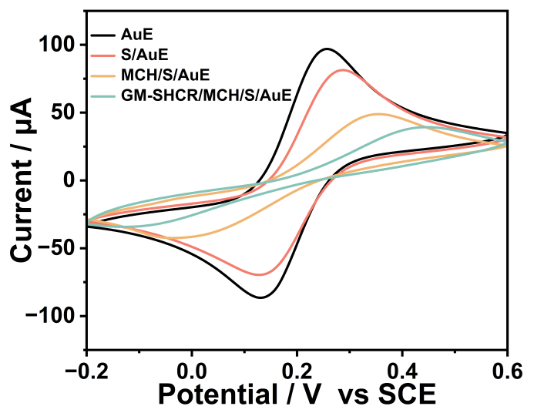
Figure S2. CV characterization of the stepwise electrode modification process.

Comparison of homogeneous and heterogeneous amplification signals
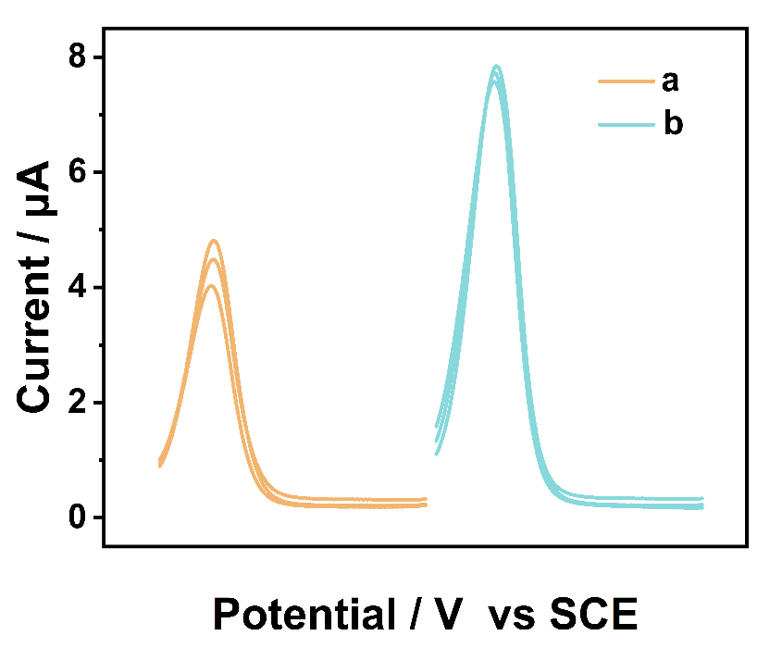
Figure S3. DPV response of (a) the electrode interface in situ amplification and (b) homogeneous amplification and then immobilization on the electrode interface (miR-141 concentration: 1 pM).

Control experiment using different amplification strategies
(1) Only the hairpin-structured DNAzyme-assisted target recycling amplification (Cycle I)
Figure S4. (A) DPV curves of this biosensor based on only the hairpin-structured DNAzyme-assisted target recycling amplification (miR-141 concentrations: 0, 1 fM, 10 fM, 100 fM, 1 pM, 10 pM, and 1 nM). (B) Corresponding calibration curve of peak currents versus the logarithm of miR-141 concentrations. Error bars indicate standard deviations from three repeated measurements.
(2) Only the SHCR amplification (Cycle II)
Figure S5. (A) DPV curves of this biosensor based on only the SHCR amplification(miR-141 concentrations: 0, 1 fM, 10 fM, 100 fM, 1 pM, 10 pM, and 1 nM). (B) Corresponding calibration curve of peak currents versus the logarithm of miR-141 concentrations. Error bars indicate standard deviations from three repeated measurements.

Selectivity of Electrochemical Biosensor
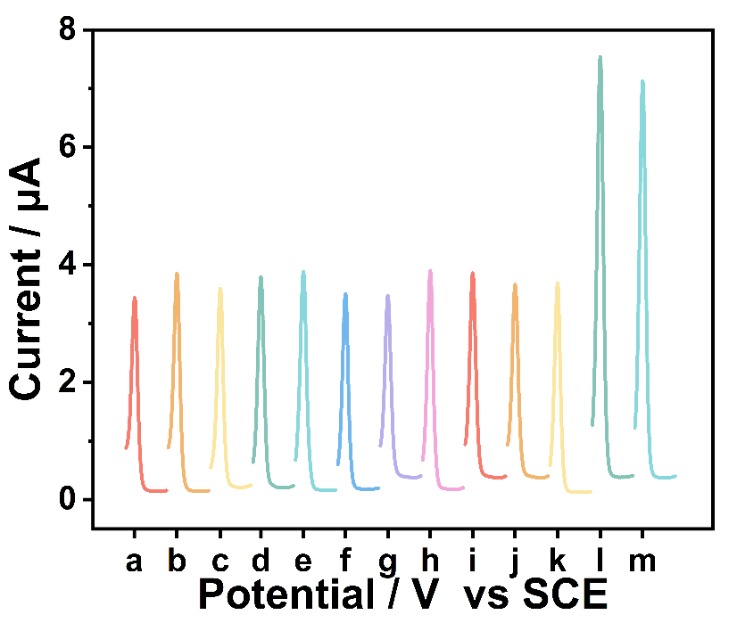
Figure S6. DPV curves of the biosensor in response to a. black；b. survivin mRNA; c. miR-34b; d. miR-34c; e. miR-122; f. miR-107; g. let-7a; h. miR-144; i. TK1 mRNA; j. mis141-1; k. mis141-3; l. miR-141; m. mixture (miR-141 concentration: 1 pM, other RNAs: 100 pM).

Reproducibility of the S DNA-modified electrode
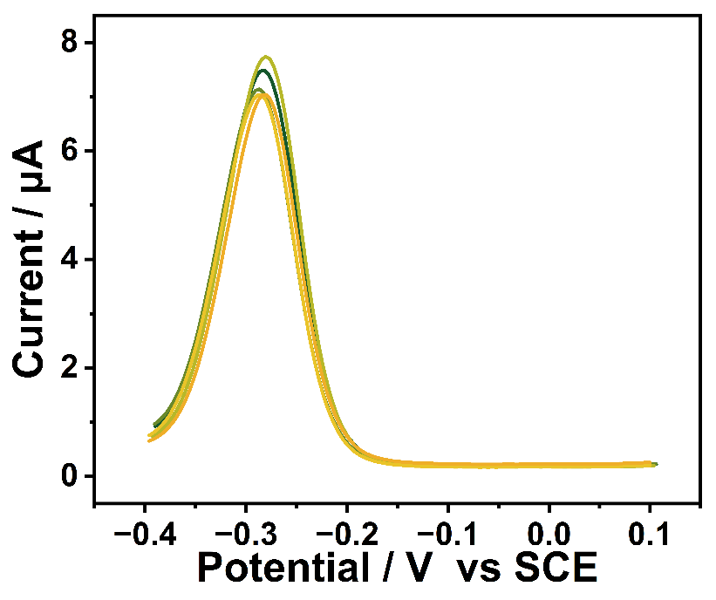
Figure S7. DPV curves of this biosensor response to five-batch-modified electrodes in the same condition, the concentration of miR-141 is 1 pM.

Storage stability of the S DNA-modified electrode
Figure S8. (A) DPV curves and (B) peak current of the S DNA-immobilized electrodes stored for different days under 4 ℃ for the detection of miR-141 (1 pM). Error bars indicate standard deviations from three repeated measurements.

Spike-recovery experiments for miR-141 detection in fetal bovine serum
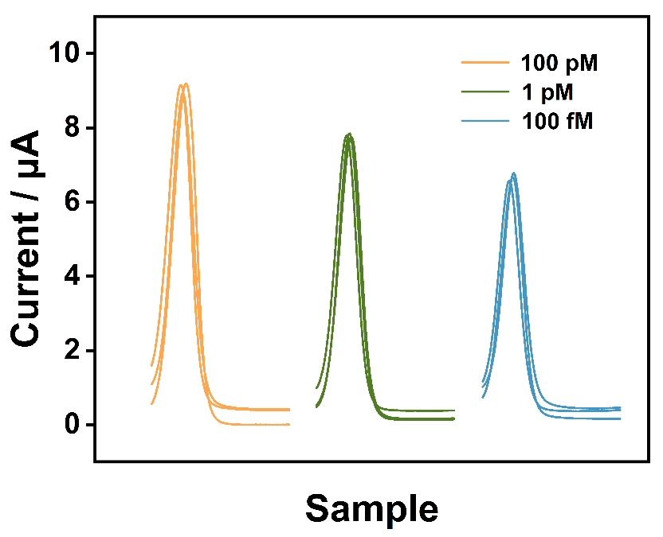
Figure S9. DPV curves of miR-141 detection in fetal bovine serum.

Detection of miR-141 in different cell lysates
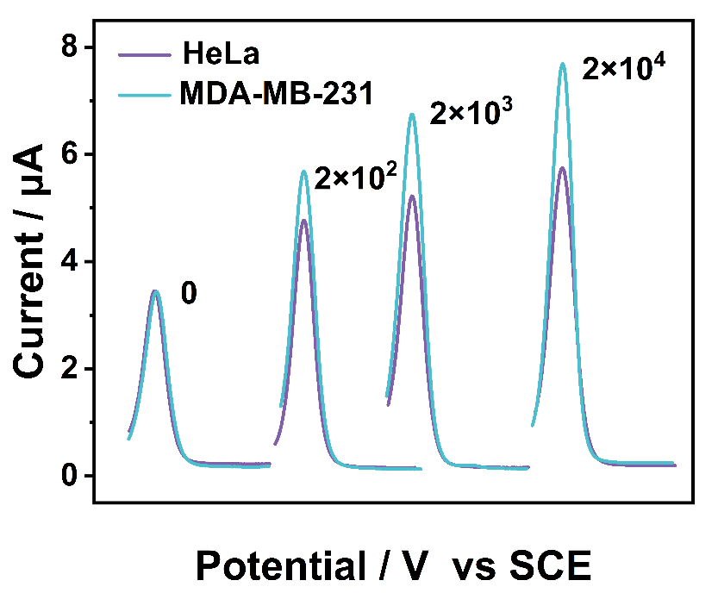
Figure S10. DPV curves of miR-141 expression levels in cell lysates.

Table S1. All the DNA oligonucleotide sequences involved in this work.
Name | Sequence (5′–3′)
R | CCATCTTTACCAGACAGTGTTAGCAGTTGATCCGCAGCTCTGTCTCCAAAGGATCAACTGCTAACACTGT
miR-141 | UAACACUGUCUGGUAAAGAUGG
L1 | TTTTTTTTTTGGAGCAGTTGATCCTTTGGAGACAGAGCTGC
L2 | CAAAGGATCAACTGCTCCGAGCCGGTCGAAATAGTGGGTG
H1 | CCACCACATACTAAAACACCCACTAT/rA/GGCAGTTGATTTACGAGGCGGTGGTGGAGCCAGAC
L3 | GGCAGTTGATTTACGAGGCGGTGGTGGAGCCAGAC
L4 | TCGATGTCTGGCTCCACCACCGC
L5-SH | SH-TTTTTGTCACTCGTCCGAATCAGCACT
G4-H2 | GGGTAGGGCGGGTTGGGTTTTTCTGGCTCCTGTGATTGTGCTTTACATCGGCACAATCACAGG
G4-H3 | GGGTAGGGCGGGTTGGGTTTTTGCACAATCACAGGAGCCAGTTTCCTGTGATTGTGCCGATGT
P-SH | CTAGAGCACAATCACAGGAGCCAGACATCGATTTTT-SH
S-SH | SH-TTTTTAGTGCTGATTCGGACGAGTGTC
one-base mismatched miR-141 | UAACACUCUCUGGUAAAGAUGG
three-base mismatched miR-141 | UAACACUCUCUGCUAAAGAUGC

Table S2. Electron-transfer resistance (R_{et}) values obtained from EIS measurements during the stepwise electrode modification process.
Electrode | R_{et} (Ω)
AuE | 170.2±3.9317
S/AuE | 8954±87.919
MCH/S/AuE | 19,769±103.73
GM-SHCR/MCH/S/AuE | 25,167±209.18

Table S3. Comparison of this work with other cascaded amplification strategies
A  nalytical Method | Amplification Strategy | Detection Limit | Ref.
Electrochemistry | CTSDR-HCR | 0.43fM | S1
Electrochemistry | MNAzyme-CHA | 0.36 fM | S2
Electrochemistry | CHA-DNAzyme | 2.5fM | S3
Electrochemical | HCR-Exo III | 0.15 fM | S4
Photoelectrochemical | EXPAR-CRISPR/Cas12a | 0.92 fM | S5
electrochemiluminescence | 3D DNA walker-RCA | 0.14 fM | S6
Fluorescence | DNAzyme-CHA | 11 fM | S7
Fluorescence | DNAzyme-CHA | 5.4pM | S8
Electrochemistry | DNAzyme-SHCR | 18.8 aM | This work

Table S4. Spike-recovery experiments for miR-141 detection in 10% fetal bovine serum
Samples | Added | Found | Recovery（%） | RSD(%,n=3)
1 | 100pM | 94.52 pM | 94.52 | 1.26
2 | 1 pM | 1.175 pM | 117.47 | 0.62
3 | 100 fM | 97.60 fM | 97.60 | 1.37

References
S1. Cheng, W.; Pan, H.; Chen, J.; et al. Enzyme-free and triple sensitivity amplification for electrochemical detection of exosomal microRNA. Anal. Chem. 2025, 97, 5244–5250.
S2. Xie, X.; Chen, P.; Wang, J.; et al. A high-efficiency electrochemical biosensor based on AuNPs@Zr-MOF and enzyme-free cascade signal amplification for microRNA detection. Sensor Actuat B-Chem. 2025, 445, 138609.
S3. Yang, H.; Jin, Y.; Qian, H.; et al. Target-driven cascade amplified assembly of covalent organic frameworks on tetrahedral DNA nanostructure with multiplex recognition domains for ultrasensitive detection of microRNA. Anal. Chim. Acta. 2024, 1311, 342743.
S4. Shao, H.; Xue, X.; Sun, Z.; et al. Detection of microRNA-21 based on smartly designed ratiometric electrochemical sensor and dual-signal amplification. Anal. Chim. Acta. 2025, 1336, 343444.
S5. Zhang, L.; Zhang, L.; Liu, D.; et al. Exponential amplification reaction assisted CRISPR/Cas12a target-induced polarity switching photoelectrochemical biosensor for miRNA-622 detection. Sensor Actuat B-Chem. 2025, 436, 137723.
S6. Shen, T.; Yu, H.; Xu, X.; et al. Bimetallic nanoclusters and dual-amplification tactic: an ultrasensitive electrochemiluminescence biosensor for miRNA-21 detection. Anal. Biochem. 2025, 706, 115948.
S7. Chao, Q.; Zhao, J.; Li, J.; et al. ATP-accelerated DNA hexahedron nanoreactors: Spatially confined DNAzyme-CHA cascaded amplification for ultrasensitive live-cell imaging of miR-21. Biosens. Bioelectron. 2025, 289, 117930.
S8. Huang, X.; Li, Z.; Tong, Y.; et al. DNAzyme-amplified cascade catalytic hairpin assembly nanosystem for sensitive microRNA imaging in living cells. Anal. Chem. 2023, 95, 11793–11799.

